Programme and Abstract Book

Belfast Eye Conference

22nd and 23rd June 2024

Hosted virtually by

Queen’s University of Belfast
https://share.medall.org/events/belfast-eye-conference-2024

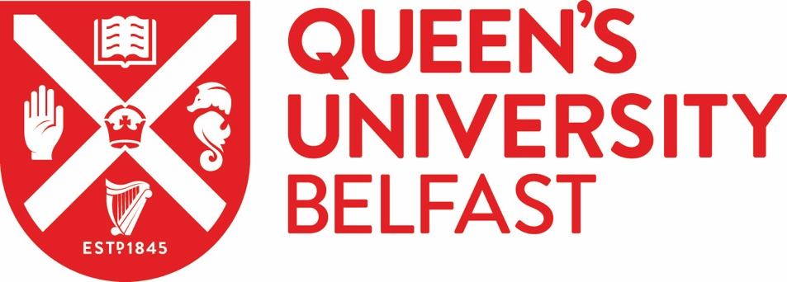

AVAILABLE FROM 1st June 2024

